Beatrice – 3 year old Saanen/Nubian cross in milk, produces a gallon and a half a day

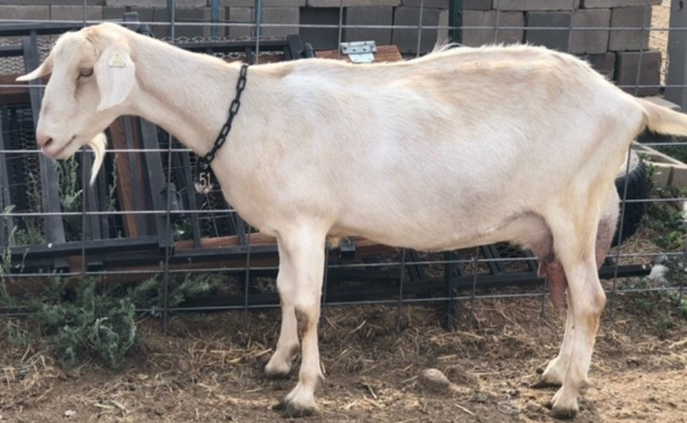

Betty – 3 year old Saanen in milk, produces a gallon and a half a day

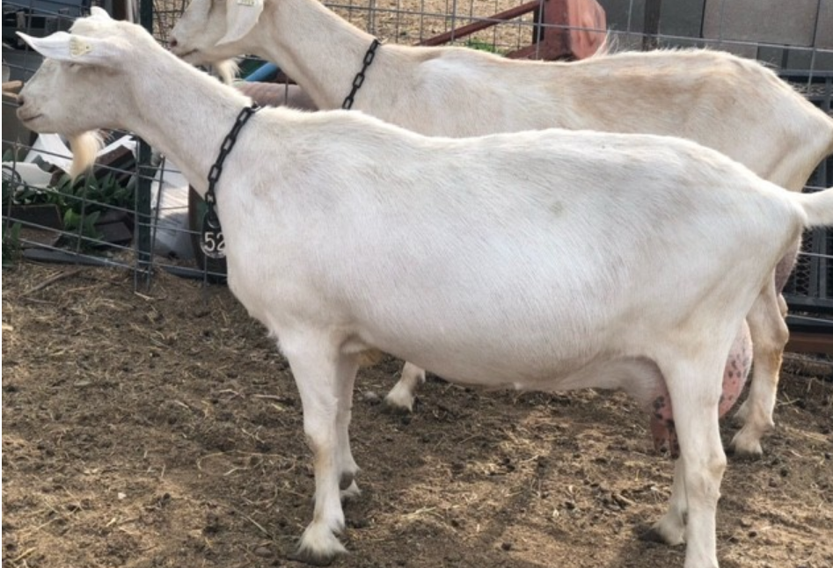

Patches – Nubian doe in milk, produces a gallon per day

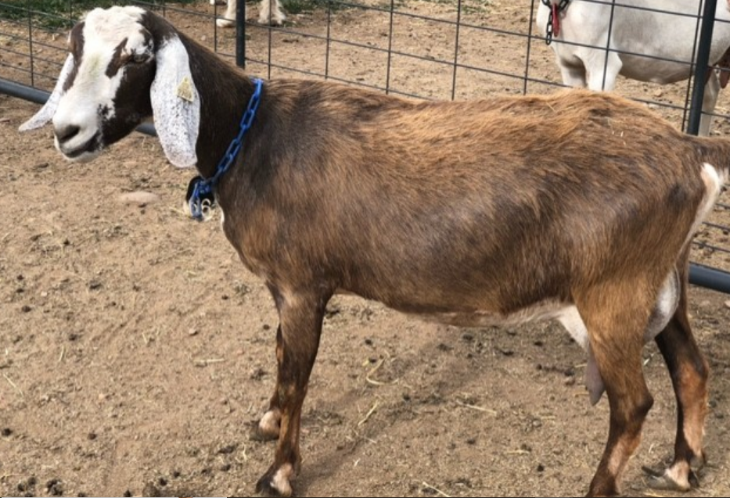

Triskit – Saanen/Nubian cross doe in milk, produces ¾ of a gallon per day

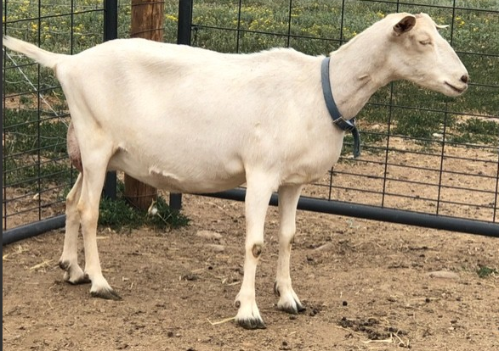

Dry Saanen yearlings

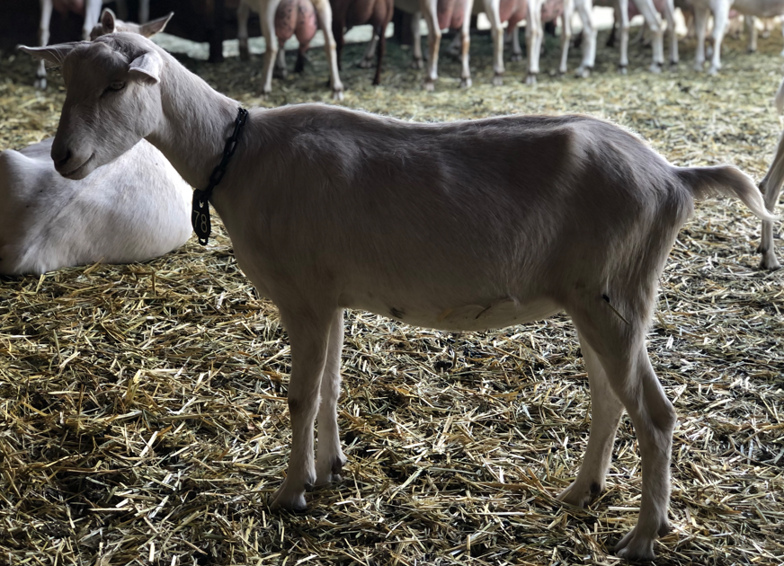

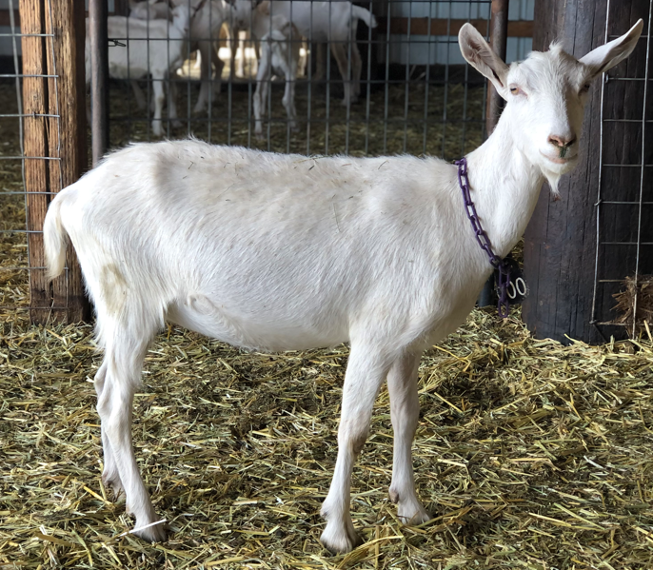

Nubian kids

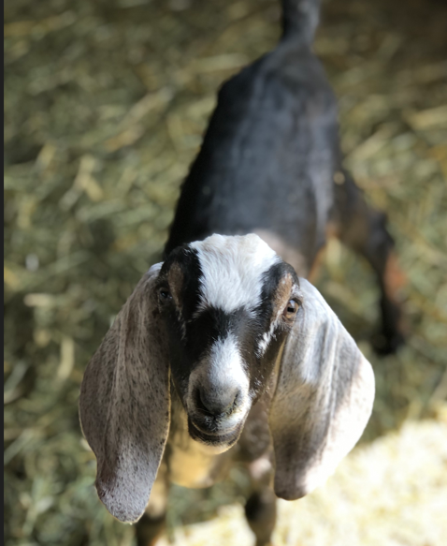

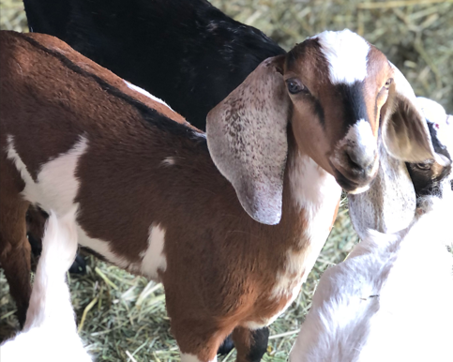

Saanen kids

